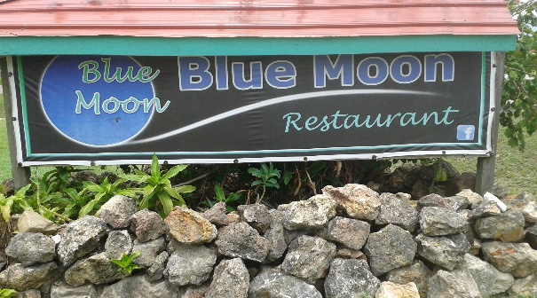
Second Annual
Blue Moon Charitable Triathlon
“You Only Have What You Give”
City of Belmopan Contact: 624-5450
Sunday, July 30, 2017 822-4433
Time: 10:00 a.m. mchspbz@yahoo.com

For Official Use Only
Registration Form

Contact Information
Date Rec’d: ___/____/____/
DD / MM / YY
Registration Paid: ___________

Receipt Number: ___________
Comments:
- Registration fee: $400 per team
- Payment to:
Blue Moon Restaurant
Belize Bank, City of Belmopan
Acc’t #: 64501118846
- Registration deadline Monday, July 11, 2017.
- Teams are responsible for providing their own canoes, paddles, bicycles and other triathlon paraphernalia.
- Any changes in participants must be submitted to the organizers before the start of triathlon.
- All participants must be present during the award ceremony in order for teams to receive their prizes.
- Help us support Marla’s House of Hope.

Blue Moon Restaurant Representative
Team Name:
Team Captain:
Contact Person: | Tel:
Email:
Sponsor:(Company Name)

Paddler Information
Name 1:
Name 2:

Cyclist Information
Name 3:

Runner Information
Name 4:

Note: Every team must have at least one female participant.
Triathlon Description
Leg 1 Canoeing: Starts at Central Farm ferry, ends at wooden bridge, Iguana Creek.
Leg 2 Cycling: Starts at Iguana Creek wooden bridge, to Blue Moon Restaurant in Belmopan Once around the round about and back to the Blue Moon.
Leg 3 Running: Starts at Blue Moon Restaurant, one lap around the Belmopan Ring Road and ends at the Blue Moon Restaurant.
Triathlon Prizes
- First Prize: $1,000
- Second Prize: $750
- Third Prize: $500
- All participants will also receive a medallion on a ribbon.
By signing this form, I acknowledge that I understand The Blue Moon Charitable Triathlon rules which we pledge to abide by at all times. The participants and I also understand that The Blue Moon Charitable Triathlon organizers and/the Blue Moon Restaurant will not be held liable for any accident to person, damage to property or similar occurrences that may arise during the course of the triathlon.

